Title | Ms. | First Name | Neeru | Last Name |  | Jain | Photograph
Designation |  | Associate Professor |  |  |  |  | 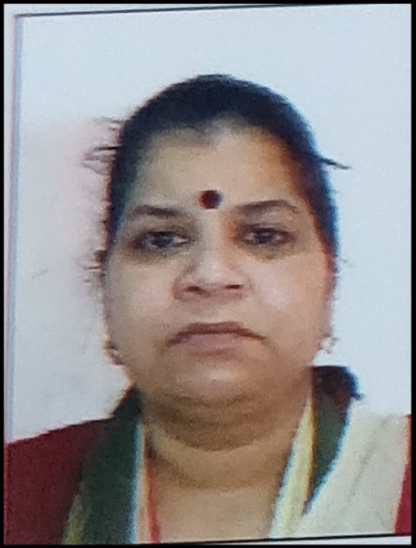
Department |  | Mathematics
Address  (Campus) |  | SPM College (for women) Road no. 57 Punjabi Bagh (West) New Delhi-110026
Phone Number(Campus) |  | 25224499
Fax |  | 25221672
Email |  | neerujain@spm.du.ac.in
Education |  | M.Phil. (Mathematics)
Subject |  | Institution |  |  | Details
1) B.A. Hons.  (Maths)  2) M.A/M.Sc.  (Maths)  3) M.Phil. (Maths)  4) UGC JRF/NET |  | Maitreyi College, DU  Hindu College, DU  Department of Mathematics DU  UGC |  |  | 1986  1988  1990  1988
Research Interests/ Specialization
General Topology

Teaching Experience
30 Years (Approx.)
Participation in Conferences/Workshops:
- Participated in the Two-Day National Workshop on ‘Groups & Geometry’ organized by the Department in collaboration with The Indian Mathematics Consortium in August 2019.
- Participated in FTP for online teaching on M.S. Teams Software in August 2020.
- Co-convener of online Maths Quiz conducted by the Department in 2021.
- Participated in UGC Sponsored National Seminar on ‘Application of Mathematics in Social Sciences’ conducted by Seminar Committee of the Department in March 2022.
- Co-Convener of Workshop on ‘Differential Equations with R & Matrix Calculator’ conducted by the Department in October 2022.
- Participated in Seminar on “Expanding the domain of Indian Languages in Mathematics & Science” organized by Bhartiya Bhasha Samiti (Ministry of Education GOL) & SPM College University of Delhi in November 2022.
- Participated in Workshop on ‘life skills’ jointly organized by the Department of Mathematics & Department of Computer Science in November 2022.
- Organized following departmental activities as the TIC of the Department being convener in two of these activities and co-convener in one of the activities during 2023-24
- Talk on ‘Women in Mathematics Education’ held on 10th June 2023
- Orientation Program for newly admitted students of 1st year B.Sc. (Hons.) Mathematics held on 17th August 2023.
- Seminar On Project And Application Based Learning organized held on 11th October 2023.
- Career Counselling Session by the Alumni held on 18th October 2023.
- Inter College Maths Quiz competition held on 18th October 2023.
- Workshop on Vedic Mathematics held on 29th November 2023.
- Online intercollege Poster Making Competition held from December 12 to December 21, 2023

Counselling for Progression in Higher education for Stem courses in the UK held on 7th February 2024.

- Intra-college PPT Competition held on 21st February 2024.

- Career Counselling Session by Dr. Rajender Dubey from Dips Academy held on 21st February 2024.

- Talk on Professional Career Paths with Mathematics, Interactive Session with Distinguished Educators held on 10th April 2024.

Other Responsibilities
- Convener of Timetable Committee of the college (May 2018-December 2020)
- Co-Conveener & Convener of Mentorship Committee (2021-2023)

